Name ______________________________
Geometry (4.G.2)

Which shapes have exactly two pairs of parallel lines?
Select the two correct answers.

Statement | Yes or No | Explain your thinking
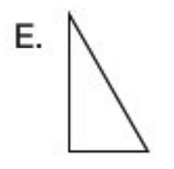
Source:
https://assessmentresource.org/wp-content/uploads/2019/08/Grade-4-Math-Item-Set-2018.pdf
Grade 4 – Spring 2018, Item M00955P

