Name ______________________________

Reasoning with Equations and Inequalities (A.REI.10)

The function $f\left(x\right)=2x-3$ has a graph in the xy-coordinate plane. Select the graph that depicts the solution set of $f(x)$.

Statement | Yes or No | Explain your thinking
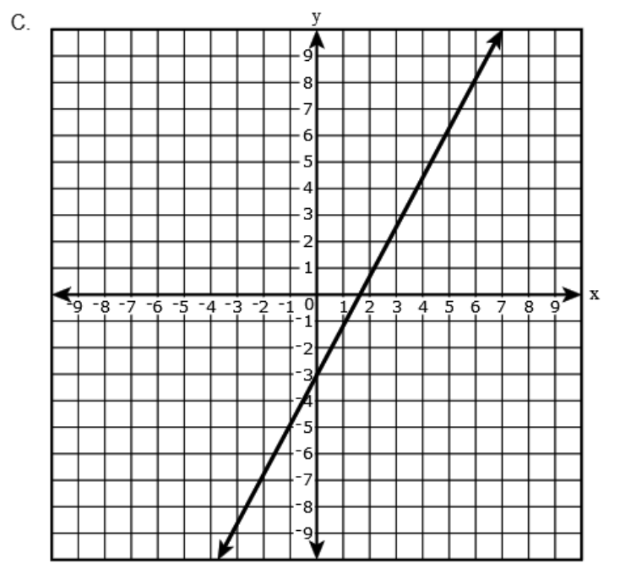

Source:
https://assessmentresource.org/wp-content/uploads/2019/07/Integrated_Math_1_EOY_Item_Set-1.pdf
Integrated Math I EOY, Spring 2015, Item M41422

