Name ______________________________

Building Functions (F.BF.3)

If k is a positive constant different from 1, which of the following could be the graph of y – x = k(x + y) in the xy-plane?

Statement | Yes or No | Explain your thinking
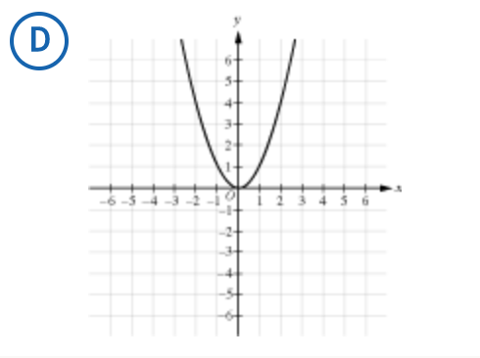

Source:
SAT Released Items
https://collegereadiness.collegeboard.org/sample-questions/math/calculator-permitted/27
Problem 27, Calculator Permitted
Heart of Algebra

